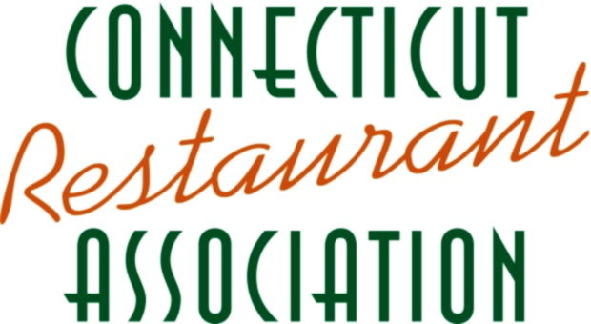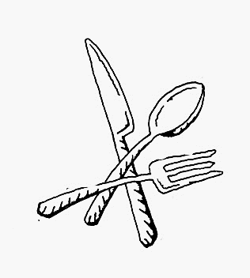

www.ctrestaurant.org

For a list of participating Restaurants visit

**Connecticut**

**Restaurant Week**

**October 10 – 16**

**Make Your Reservation Today!**