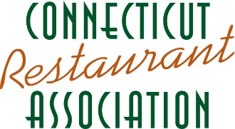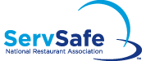
ServSafe Manager Certification Registration 2023
Our ServSafe Manager training meets the CT Department of Health requirements for food safety licensing. Learn to prevent an outbreak of a food-borne illness in your operation while earning your mandatory state Certified Food Protection Manager certification (formerly QFO). The Connecticut Restaurant Association (CRA) offers the ServSafe Manager professional development seminar, with certification by National Restaurant Association.

DATE OF CLASS____________________ LOCATION_____________________________________________________

Name (s): __________________________________________________________________________________________

Company: _________________________________________________________________________________________

Address: __________________________________________________________________________________________

City: __________________________________________________________ State: _________ Zip: _________________

Phone: ______________________________________________ Email: ________________________________________

Pre-registration: Full payment must accompany registration.
CRA Members: $159 Non-Members: $179
Sysco Customers Discount at Sysco Class (first Monday of each month): $169
Certification Only (no class): $79
In the event of a failure to certify, a retest is available for: $70
(please contact servsafe@ctrestaurant.org for a coupon code)

Materials will be provided in English unless otherwise indicated: _____ Spanish _____ Chinese ____ Korean
Sysco Customer Number __________________________
Enclosed is my check payable to: CT Restaurant Association, 270 Farmington Ave, Suite 142, Farmington, CT 06032
Bill my credit card: ___ MC ___VISA ___AMEX ___DISC
Credit Card #: __________________________ Amount: $_____________
Exp. Date: _______CVV: _______
Signature: _________________________Print Name: _______________________________

Cancellation/Rescheduling Policy: Late cancellations will be charged a $65.00 service fee, in addition to the course fee, to reschedule. Registration fees for cancellations within the late registration period and no shows CANNOT be refunded.
CRA reserves the right to cancel, reschedule or change the location of seminars one week prior.

The Connecticut Restaurant Association (CRA) strives to advance the highest quality of educational programs and promote professional career opportunities within Connecticut’s hospitality industry. For additional information, please contact servsafe@ctrestaurant.org

For more information on how to become a CRA Member, go to www.ctrestaurant.org
270 Farmington Ave, Suite 142, Farmington, CT 06032

